**Exploring Tools for Foreign Policy Analysis**:

An Agent Based Model to Assess the Impact of Foreign Aid on Coalition Formation in Libya

By Tom Pike, LTC, USA

**Abstract:** The last 16 years of conflict have shown numerous shortcomings of the United States’ approach to foreign policy. The general failure to unambiguously achieve desired outcomes indicates the U.S. Government requires new approaches and tools to analyze foreign populations and implement more effective foreign policy. To this end, this research develops an Agent Based Model (ABM) for coalition formation and then employs it using a qualitative assessment of Libyan groups. The model successfully reproduces known coalitions and shows general agreement with the impact of foreign aid based on experiences in Afghanistan. These results provide evidence to support the further exploration of ABMs as scalable computational analytic tools which can improve both analysis and policy exploration and formulation across the U.S. Government.

*The views in this paper are purely those of the author and do not reflect the views of the U.S. Government, Department of Defense or U.S. Army*.

# 1. Introduction

For the last 16 years the U.S. has been involved in conflict. The U.S. has spent trillions of dollars and used extensive military resources from foreign support to direct intervention to influence the behavior of foreign populations. This expenditure has not or did not produce a clear victory in either Afghanistan or Iraq. My research is an attempt to find new ways to analyze foreign populations and the U.S. impact on the dynamics of those foreign populations. The following research represents an initial effort for that purpose.

The tool I explore is Agent Based Models (ABMs). ABMs represent a powerful tool which can allow analysts to grow *in silico* their foreign population of interest and allow staffs and decision makers to manipulate those models to develop a better understanding of the impact of their policies. ABMs are no panacea to produce miraculous foreign interventions or correct results, instead they are computational enhancements to aid analysts and decision makers to help them explore complex phenomenon more effectively (R. Axtell 2000; Epstein 2006).

The topic I explore is coalition formation in Libya. I chose Libya because it is an ongoing civil conflict of strategic importance. The choice of a contemporary conflict provides insights into the challenges of getting an accurate understanding of local dynamics due to sparse research and data.

There is substantial literature surrounding ABMs, the Libyan conflict and more generally political science and even political science with the use of ABMs. Although there is a lot of research in these areas, I was unable to find any research which used ABMs or other simulations to study Libya.

Exploring new tools to understand the impact of U.S. actions on foreign populations which are accessible across all levels of government is essential to improve the results the U.S. seeks in conflicts overseas. To this end, I developed an ABM which assesses coalition formation based on analytic inputs and conducted a qualitative assessment of Libya. I then inputted this assessment into the model to see if I could replicate known coalitions in Libya and then simulated the impact of substantial foreign support to one group and then many groups. The result was synthetic coalitions which agreed with known Libyan coalitions as well as general agreement with experiences in Afghanistan on the impact of foreign aid on a group’s decision to form coalitions or compromise on its position. These results demonstrate that ABMs are a tool worth pursuing in finding new and innovative ways to improve U.S. foreign policy development and implementation.

# 2. Method of Analysis

I used two methods for assessing the impact of foreign aid in the forms of economic and military support to Libya. The first was to develop a qualitative assessment of major groups, their affinity (which can also be understood as ideology), their economic resources and their military capability. The second was the instantiation of this assessment into an agent based model (ABM), where each group was an agent. The agents then determined their optimal coalition formation using the bilateral Shapley value as the agents’ decision algorithm (Ketchpel 1995). I programmed the ABM using Python 3.6. The use of the ABM with a well-known game theoretic algorithm at its core allowed for a way to test the accuracy of the qualitative assessment of a complex situation in a data sparse region against known phenomenon. The intent of this process was to develop a computational aid to foreign policy analysts and decision makers who must make decisions with limited information. The model itself can take the qualitative assessment of any foreign population at multiple scales. Due to this capability, it produces two types of results. First, results which are specific to the coalition formations of Libya. Second, generalizable results which are based the model dynamics.

2.2 Qualitative Assessment of Libya

A basic historical background of Libya’s civil war is necessary to understand the qualitative assessment of Libya’s groups. The Arab Spring spread to Libya in February 2011 resulting in a revolt against Gaddafi’s government which had been in place since 1969. Gaddafi began violently suppressing the uprising. In March 2011, the United Nations voted for a no-fly zone over Libya to protect civilians. The North Atlantic Treaty Organization executed the no-fly zone tipping the balance of power against Gaddafi’s security apparatuses. By August 2011 Gaddafi’s rule was effectively over as the General National Congress (GNC) took control of the government from the National Transition Council. On October 20, 2011 Gaddafi was captured and then killed. Libya continued to make the rough transition to a new form of government, which erupted in a second phase of civil war beginning in 2014. Elections in June 2014 resulted in a defeat from Islamist dominated GNC, who refused to step down. The elected House of Representatives (HoR) tried to assume control of the government resulting in conflict between these two groups. In addition, Islamic Extremists such as Al-Qaeda and the Islamic State had taken or took control of the cities of Sirte, Benghazi and Derna. Through the resulting conflict the HoR fled Tripoli to Tobruk. In Janaury 2016, the United Nations tried to broker a peace agreement which produced the Government of National Accord (GNA). The HoR and GNC do not recognize this new government although the international community recognizes it as the official government of Libya (see timeline figure 1). Since 2016 the HoR, allied with General Haftar who commands the Libyan National Army (LNA), has made steady progress eastward from Tobruk fighting extremists in Benghazi and Derna as well as securing the major oil revenue pipelines. The LNA is stopped outside of Sirte, and major push into Sirte would signify the beginning of a conflict between the LNA and the powerful Misratan militias who seized Sirte from extremists in late 2016.

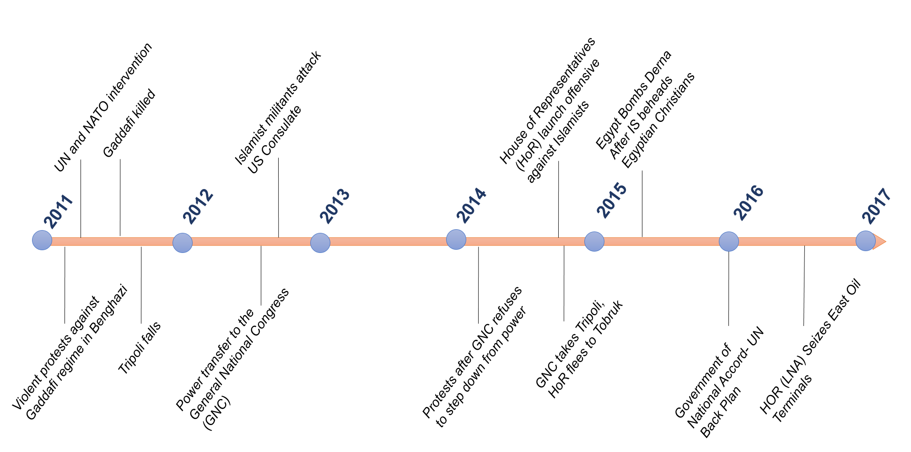

**Figure 1**: Timeline of events in Libya since 2011

Although the previous description produces a succinct narrative of Libyan events, it like the following ABM is a simplistic model of reality. At the local level civil war is known to be a highly fluid situation of changing coalitions and local fights leveraging the warring factions for their own ends (Kalyvas 2006). To try and model these dynamics I first assessed the heterogeneity of the population. Libya has approximately 140 tribes and although Gaddafi tried eliminate the tribes as a part of Libyan identity they still offer a fair representation of the different views of Libyan society (Hatitah and Al-Awsat 2011; Tempelhof and Omar 2012; Masson and Freidel 2012; Eriksson 2016). A literature review produced no comprehensive study of Libyan tribes. I therefore pieced together a list of 128 tribes and groups through a variety of sources. Detailed information of all the tribes was lacking, however there were several studies which described local dynamics in different places throughout Libya which allowed for a qualitative assessment of these tribes (Lacher 2011; Fitzgerald 2015; Eriksson 2016; Boduszyński 2015; Cole and Mangan 2016; Cole and McQuinn 2015). I then compared this assessment with population estimates. The result was there still several areas particularly in the more densely populated west for which there was not detailed information. To account for these populations I made inferences based on geographic alignment and historic coalitions to account for these groups. I also accounted for groups of people who not affiliated with any major tribe which were aligned with various ideologies in urban centers.

The second step in the qualitative assessment was determining a group’s affinity. I included this attribute due to the well-known homophily affect in which people generally chose to align with those most like themselves, which is also an essential element of trust in civil war (Macy and Willer 2002; Kalyvas 2006). A group’s affinity score is based on a qualitative assessment of where the group would fall in a spectrum between 0 and 10. Based on the historical background there were three points on this spectrum which represented various ideologies. First, an afifnnity score near 3.0 represents nationalists. Groups who had more secular leanings and generally looked to historical precedent to shape their views of Libya’s future. Second, 6.0 represents fundamentalists. Groups who wanted a more religious society were closer to 6.0, with more fundamentalist groups that followed Salafist traditions (Islamic tradition most closely associated with Saudi Arabia) had higher scores closer to 7 or 8. Islamic extremists, most closely associated with zealots such as Al-Qaeda or the Islamic State had scores at 9 and above. I discuss the impact of affinity on coalition formation in detail in the section describing the model.

The third step was assessing power of each group. I used the average of two variables, economic resources and military capability to assess a group’s power. I determined the group’s economic resources based on their geographic location and assessed access to major revenue sources on a scale from 0 to 10. Qaddafi had a large government which by some estimates employed up to 80% of the population (Elgazzar et al. 2015). Post-Qaddafi Libya has two major revenues sources, trade between Europe and Africa (much of it illicit) and oil (Shaw and Mangan 2014; U.S. Energy Information Administration 2016). An assessment of the group’s access to trade revenue and oil revenue accounting for damaged infrastructure as of spring 2017 formed each group’s economic resources value. I was unable to find detailed descriptions of different militia organizations military hardware (tanks, planes etc) and leadership (ability to leverage these resources and command a following). Each group’s military capability value was assessed based on demonstrated capability and known foreign support. For example, Egypt provided air support to LNA actions against extremists in Derna and generally appears to provide military support to the LNA (“Egypt Launches Strikes in Libya after Minya Attack | Egypt News | Al Jazeera” 2017; “Khalifa Haftar Forces Capture Key Libya Oil Terminals | Libya News | Al Jazeera” 2017).

The qualitative assessment of Libya’s groups involved three parts. One, categorizing the population into groups along generally tribal lines. Two, assessing each group to determine an affinity value on a 0 to 10 spectrum, which ranges from nationalists and secular on the left (towards three) and fundamentalists on the right (towards six). Three, assessing each group to determine a power values based on access to economic resources and demonstrated military capability. My assessment of the various groups and their affinity, economic resources and military capability values are located in appendix A. This assessment was then placed in a comma separated value (csv) file and served as input to the agent based model.

To assess the impact of foreign aid to I ran three variations of these values. The first variation was the assessed values to determines if the model replicated known alliances. The second variation injected a large amount of military and economic aid into the first group in the list (al-Ubaidat) increasing its economic and military values to 99. The third variation then increased the aid for leading tribes in Tobruk (Al-Ubaidat), Bani Walid (Sadat) and Sabha (Awlad Suliman) to 33 for their respective economic and military values. These increases are significant since the highest economic or military value prior to this additional foreign aid was six.

2.2 Agent Based Model

The agent based model has five steps. First, the input and instantiation of agents with qualitative assessment of each group. This step includes inputting a marginal effectiveness parameter value and a compromise parameter value. Second, each agent would then examine every other agent and using the bilateral Shapley value determine their preferred matches. The agents would then form an coalition with their most preferred group. Third, the two agents who formed a coalition would form a new agent, with a new combined affinity and power value. Steps two and three would repeat until there were no more coalitions formed. In step four, the original groups would reexamine their coalitions and ensure their bilateral Shapley value continued to support the coalition, if not the groups would break their coalition. The fifth and final step was an output csv which record all the groups and the subgroups affinity and power values (see figure 2).

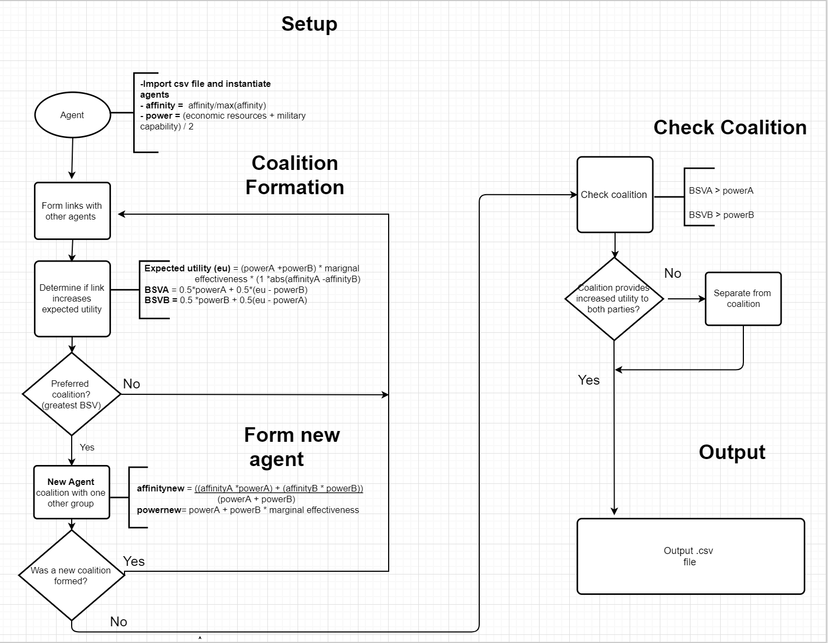

**Figure 2**: Flow Diagram of Agent Based Model

The first step of the model reads in a group based assessment of any foreign population with affinity, economic resources and military capability values. The model normalizes affinity the inputs by dividing each group affinity by the maximum group affinity to produce an affinity score between 0 and 1. The model then reads in the group’s economic and military values and takes the mean. This requires the economic and military values to be assessed on the same scale. Each agent is then instantiated with their respective affinity and power values.

Step two of the model is to form coalitions. To do this each agent (group) determines the expected utility of forming an alliance with every other agent. The expected utility is calculated using

${v\left(AB\right)= (A}_{power}+B_{power})*ε*(1*\left|A_{affinity}-B_{affinity}\right|)$

Where $ε$ is the marginal effectiveness parameter and *v(AB)* is the expected utility of the relationship (Abdollahian, Zinig, and Nelson 2013). The expected utility is then used to calculate the bilateral Shapley value using

$BSV\left(A\right)= \frac{1}{2}A_{power}+\frac{1}{2}(v\left(AB\right)-B_{power}$)

Where *BSV(A)* is the bilateral Shapley value for one group. If the BSV for both groups is higher than their own power value then the BSV is stored as a potential coalition. After all potential coalitions are assessed then each agent is paired with the best possible coalition and a new agent (group) is formed (Ketchpel 1995) . This then leads to step three.

Step three forms a new agent (group) from the coalition which formed. The new agent affinity is calculated using

$$C_{affinity}= \frac{A_{affinity}*A_{power}+B_{affinity}*B_{power}}{A_{power}+B_{power}}$$

Where C is the new coalition (agent) which has formed (Abdollahian, Zinig, and Nelson 2013). Of note, the new coalition influences the affinity value of its component parts but they do not completely adopt the new affinity. After a group decides to join the coalition its affinity value updates using

$$A_{affinity}={A_{affinity}+(C}_{affinity}-A_{affinity}* γ)$$

Where $γ$ is the inputted compromise parameter determining how much of an affect the new coalition has the group’s affinity values . The new power of this group is

$$C_{power}= {(A}_{power}+B_{power})*ε$$

Where C represents the new coalition’s (agent’s) power and $ε$ represents the marginal effectiveness parameter placed in the model. After the new agents form, steps two and three repeat themselves until no new coalitions are formed.

In step four each group in the coalition assesses whether they should remain. Each group and the coalition computes their *v(AC),* the expected value of remaining in the coalition, and their respective bilateral Shapley value. If the BSV for the group is higher in the coalition than without it then the group remains. Otherwise, the group removes itself from the coalition and two new agents are formed. The coalition without the group and the group as a new agent.

After this step is complete the model concludes with step five which outputs the information about the coalitions and their sub-groups into a csv file for analysis.

# 3. Results

Results from the 150 simulations over the three varying conditions of no new foreign support (no support), a large amount of foreign support to one group (all support to one), and large amount of foreign support to three groups (distributed support) shows an increase in the compromise parameter and marginal effectiveness parameter results in a quicker coalescence to one group (figure 3). The marginal effectiveness parameter has the most impact over small range of 1.1 to 1.6 with any compromise parameter above 0. 4. A low compromise parameter of less than 0.3 combined with a marginal effectiveness parameter between 1.1 and 1.4 shows the greatest variability both in different numbers of tribe formations and the affinity parameter of the larger group alternating between fundamentalist majorities and nationalist majorities. Foreign support to one group (al-Ubaidat) has the largest impact on coalition formation. The impact, however, varies based on the conditions as the supported group and associated coalition size goes down under certain marginal effectiveness parameters and up under others. Distributed support has no effect on coalition formation producing the same results as in the no support runs, with the primary impact being an increase of power for the support groups. Altering marginal effectiveness had the greatest impact on coalition formation, while foreign support had minimal impact on coalition formation except under specific marginal effectiveness inputs.

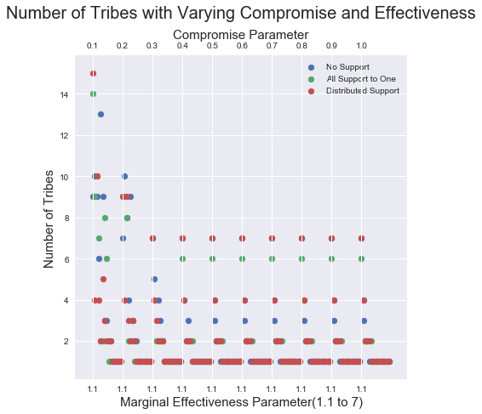

**Figure 3:** Results of 150 simulation runs

The two tuning parameters had a large impact on the overall model results. Of the two, marginal effectiveness had the larger impact. If the marginal effectiveness had a value of one, no tribes coalesced for the simple reason, there was no added benefit to forming an coalition with a group of a slightly different opinion. However, even a small increase from 1.0 to 1.1 resulted in a benefit that could offset the dampening effect of the difference in affinity values. Any marginal effectiveness value over two resulted in all groups allying with each other. As the compromise parameter went up the marginal effectiveness parameter at which the different groups coalesced into one coalition went down. The impact of the parameters can then be viewed as a identifying a boundary between no coalitions being formed (marginal effectiveness parameter < 1; compromise parameter = 0) and every group forming a single coalition (marginal effectiveness parameter ­> 2; compromise parameter > 0.3). The most interesting behavior of the model occurred within this boundary.

The marginal effectiveness parameters of 1.2, 1.3, and 1.4 and compromise parameter of 0.1, 0.2, and 0.3 showed the most variation in the results. As mentioned previously the affinity of each group was placed on a spectrum from 0 to 10. Groups with nationalist and secular leanings (nationalists) were closer to 3.0 on the scale, Islamists (fundamentalists) were closer to 6.0, Islamic Extremists (e.g. Da’esh, ISIS, Al-Qaeda) (extremists) were closer to 9.0 and higher, and minority groups typically outside the main structures were closer to 1.0 and lower. Parameter inputs of 1.1 for marginal effectiveness and 0.1 to 0.3 showed the highest spread of groups with roughly three fringe groups who are non-allied groups on the extreme (> 9.0 or < 1.0) and then two to four medium sized groups spread across the rest of the spectrum. A marginal effectiveness setting of 1.2 and a compromise setting of 0.2 would result in seven fringe groups and three large groups, with a moderate affinity (0.56) as the largest (48) and most powerful (108.84). Increasing the compromise parameter to 0.3 reduced the fringe groups. The reduction of fringe groups by increasing the compromise parameter also occurred with an increase in the marginal effectiveness parameter, indicating that the effect of the compromise parameter is to bring fringe groups into larger coalition formations. Interestingly, the increase of the marginal effectiveness parameter results in a majority of fundamentalists or nationalists depending on the parameter. At a 1.3 marginal effectiveness parameter, the fundamentalists have the majority and at a 1.4 marginal effectiveness parameter the nationalists have a majority (figure 4 and 5). It is also important to point out that the majority is more moderated (closer to five) while the minority is more extreme (close to 9 or 1). These results are all under conditions of no new foreign support as well as foreign support distributed to three groups.

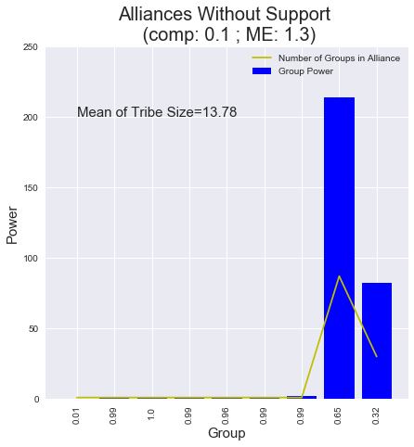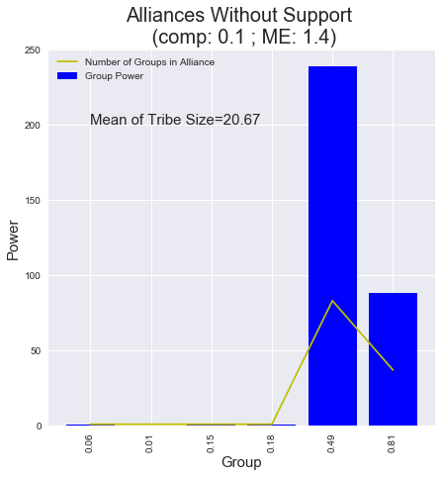

**Figure 2:** Coalition formation with fundamentalist **Figure 3:** Coalition formation with nationalists gaining a majority at 1.3 marginal effectiveness gaining a majority at 1.4 marginal effectiveness

Providing a large amount of foreign support to one group does change the affiliation dynamics within the boundary condition. Increasing the compromise parameter continues to reduce the number of fringe groups, while a marginal effectiveness parameter of 1.1 increases the size of the non-supported moderate large coalition (affinity 0.54) from 37 to a coalition of 45 groups (affinity .55) while the supported group (affinity .33) only increases by 1 to 25 (affinity of 0.3). As the marginal effectiveness parameters increases to 1.3 the 0.32 affinity coalition (supported group) goes from 30 to 49 (new affinity of 0.34), while the 0.65 affinity coalitions goes down from 87 to 67 (new affinity of 0.69). Interestingly, the impact of foreign support at a marginal effectiveness of 1.4 is to cause a more right leaning affinity to gain a majority which they did not gain in the non-supported model run. The 0.49 affinity coalition (supported coalition) went from an 83 group coalition to a 29 group coalition with a new affinity of (0.3) while the more extreme affinity coalition went from a 0.81 affinity and a 37 group coalition to 0.65 affinity and a 90 group coalition. From these results, support to a group on the left of the affinity scale had the affect of making a larger coalition on the right side of the spectrum, although it was not as far to the right. Support to one group on a specific part of the affinity spectrum has an interesting affect of increasing coalitions with a marginal effectiveness parameter of 1.3 but strengthening the non-supported group with a marginal effectiveness parameter of 1.1 and 1.4.

Examining the results without the specifics of the Libyan context produces three findings. First, the model has a small boundary condition which produce the most interesting results. Outside of this condition, either groups do not form or they coalesce into one group. Second, the affinity of the majority coalition changes based on the marginal effectiveness parameter, at 1.3 supporting a more fundamentalist majority while at 1.4 supporting a more moderate majority. Third, the impact of foreign aid to one group is also highly dependent on the marginal effectiveness parameter under a setting of 1.1 it has a marginal effect (increase to the supported coalition by 1), while under a setting of 1.3 it has a significant impact of increasing the supported coalition by 19, but still not making a majority and a setting of 1.4 produces a counterproductive impact causing the supported coalition to go down by 54.

# 4 Discussion

4.1 Discussion of Main Findings

Adding the Libyan context and following Axtell and Epstein’s model validation categories, I believe this model has achieved level 1 validation(R. L. Axtell and Epstein 1994) with a compromise parameter input between 0.1 and 0.3 and a marginal effectiveness input between 1.1 and 1.4. These settings produce multiple tribes with coalitions consistent with known coalitions in Libya without the addition of a substantial amount of new foreign support to one or multiple groups. The impact of foreign aid to one major group also stylistically agrees with macro-level experiences in Afghanistan, where financial and military aid to a specific group makes them more powerful, but can decrease the number of groups with whom they are incentivized to form an coalition while increasing the coalition number of potential adversaries (Kilcullen 2010). The specifics of the coalitions also produces simplistic agreement with known coalitions in Tobruk, Sabha and Bani Walid, and less detailed agreement in Sirte, Benghazi and Derna. The lack of in depth knowledge of local group affinity and power variables prevents a complete validation of coalition formation. This, however, helps emphasize the value of such models in trying to assess complex situations. Analysts can make inferences about unknown variables which can be explored and tested with the model. Placing the results of the model in the context of known Libyan dynamics shows agreement with estimates of coalition formations as well as simplistic agreement with known group coalitions.

The boundary condition has varying coalition formations which can be argued as an accurate representation of current Libyan dynamics. At its most general, this second portion of the Libyan civil war is between three major ideologies. The fundamentalists in the West, the nationalists in the East, and the extremists scattered in different strongholds. The marginal effectiveness inputs of 1.2 to 1.4 generally recreates this same phenomenon with the nationalists in groups allied from 0.3 to 0.45 and the fundamentalists allied between 0.65 and 0.81, with their being varying numbers of extremists based on how the rest of the population allies. With the input parameter of compromise 0.1 and marginal effectiveness 1.1, there are nine coalitions. There are two groups toward the middle 0.67 and 0.54, and two other groups on the extreme who are smaller at 0.81 and 0.33. Then there is a handful of non-allied groups on each end and one at 0.44 (figure 6). This can also be seen as a more specific representation of Libyan coalitions. The Libyan dawn coalition in the East collapsed. In the east there are coalitions which are more right leaning and have significant amounts of power and population, while the West has a powerful minority and at the time of the writing seems unable or unwilling to move into the more densely populated West (Cole and Mangan 2016; Fitzgerald 2015; Ronen 2016). The parameters within the boundary condition produce a range of coalition sizes and affinities which are arguably consistent with the major Libyan coalitions.

The specifics of the Libyan coalitions also show simplistic agreement with known Libyan coalitions. In Tobruk, Sa’ada tribes (which includes the al-Ubaidat) have an coalition with the Murabitin tribes (which includes Qunashat, Habun, Qutan and Mnaffa). These coalitions are replicated in the model as these groups align under the various boundary condition parameters. The reason the model shows simplistic agreement is because in reality the coalition is tense and requires very complex mechanisms to maintain the coalition which the model is unable to replicate (Kane 2015). In Sabha, the model shows coalitions with Awlad Sulaiman and Masrata tribes. The Tuareq who are active in the trading networks ally with the more moderate majority, which is arguably consistent with the role as an ethnic minority, who will opportunistically ally to serve their own purposes (Cole and Mangan 2016). The story for Bani Walid is more complex. The town is made up of five Warfalla sub-tribes (Sa’dat, Jmamla, Sabayi and 2 Mtarfa tribes). Internally, the Mtarfa feel like an oppressed minority who tried to take control of Bani Walid by aligning with Islamists after Gaddafi’s fall. Bani Walid as a city, however, was punished by Gaddafi for decades as it was seen as the origin of a failed coup in the 1990s. This made the dominate three tribes unwilling to rebel in 2011 and have tried to keep their city out of the civil war after retaking the town from the Mtarfa and more extreme Islamic groups (Cole and Mangan 2016; Cole 2015). The model does not capture these complex dynamics but it does have the Mtarfa aligning with fundamentalists coalitions while the Sa’dat, Jmala, and Sabayi align with more moderate nationalist of fundamentalist configurations. In addition, the model is able to produce extremists groups who do not ally with each other or Islamist groups. This is consistent with the role extremists have played, often being attacked by fundamentalist and driven from their strongholds as happened in Sirte which was taken by Misratan militias. Although the model cannot replicate the complex mechanisms of tribal arbitration and rich local histories, it is able to get agreement with known coalitions in Libya.

4.2 Broader Implications

Although this model focused specifically on Libya, the results of the impact of military and economic support on coalition formation are generalizable. If the goal of providing foreign support to support a group or groups is to encourage other groups within the population to align with the supported affinity then this model demonstrates that such a strategy has a small chance of success and can even be counter-productive. Although the supported group does become more powerful there was only one condition in which the supported coalition increased its number of coalitions, though it still ws not the majority, while in all the other cases it was counterproductive.

This approach also fundamentally alters the historic Westphalian perspective of a foreign country as a homogenous entity. By examining how 128 different groups may react to a large influx of outside support this model assumed a fundamentally different perspective in which foreign aid actions influence the inner workings, decisions and evolution of the foreign population. Computing the optimal coalitions of 128 groups all examining every other possibility as each new coalition changes their options is a non-trivial task which is possible through the aid of computation. As this model can take any number of groups from any population in any time period to explore it offers much greater flexibility in analyzing how coalitions within a population form and what aspects of the various groups affected those coalitions. This approach offers significant new possibilities in which to explore the impacts of foreign support to coalition formation.

4.3 Future Research

The model’s results provide the best way forward for future research. The marginal effectiveness parameter had the most impact on coalition formation. Diversifying the marginal effectiveness parameter so different groups have different attributes and whose coupling have different impacts would be a potentially powerful way to extend this model. For example, a Misrata tribe may form an coalition with an Awlad Sulaiman tribe in Sabha to create a trade route to move goods from Europe into Africa and vice versa. This coalition would have more marginal effectiveness than the Misrata tribe forming an coalition with a tribe from Al-Khums another coastal city near Misrata. This approach also provides the possibility of seeing what impact improving a specific group’s attributes may have on coalition formations. This may result in more specific foreign aid policies which have the ability to grow bottom up solutions instead of broad top down foreign policy interventions. Other important extensions of this model would be adding geographic information systems (GIS) data and diversifying the compromise parameter. The GIS extension would put tribes at a specific location and allow distance to influence their available options as well as include competition over scarce economic resources. Diversifying the compromise parameter to make some groups much likely to compromise their views may show how zealots impact the final affinities coalitions adopt. This model has many opportunities for future extensions which may enhance its results and provide more clarity to foreign policy.

4.4 Implications for Policy

These results show that an influx of economic resources and military capability may make a group within a foreign population more powerful but also discourage them from moderating their position or forming more inclusive coalitions. These results should have significant impact on how the U.S. understands the support it provides to foreign populations. Although I used Libya specifically to provide an additional layer of validation, similar dynamics should hold for all foreign populations at numerous different scales. The model can accept any csv file with the same three group variables. Although different coalitions with different spreads of affinity will emerge providing insights to that specific situation, the general impact of dramatically increasing a groups economic resources or military capability will not change.

# 5. Conclusion

Understanding the impact of U.S. foreign aid in civil conflict is a necessity based on the last sixteen years of conflict. The fact that the conflicts will keep changing and the participants will keep adapting further exacerbates this challenge. The U.S. Government requires new tool which can examine the problem in new ways and customize to the specifics of the organization or unit’s situation are required. Computational analytic tools to help analysts and decision makers explore and understand U.S. impact on local dynamics are a necessity. This model represents one small and tentative step to that objective by assessing the impact of economic and military aid on coalition formation within Libya. The first part of my research process replicated the standard qualitative assessment processes I have experienced in 17 years of military service from the platoon to the Combatant Command level. I then inputted those values into an ABM which executed a well-known coalition formation algorithm. I then analyzed those results and found general agreement of the model from two perspectives. First, the model replicated known alliances in Libya. Second, the model replicated phenomenon where groups who receive large amounts of foreign aid are less likely to form broad alliances or compromise their views. Critically, the algorithm on which the ABM operates is generalizable so any csv input can be taken for conflicts across both time and space.

# Bibliography

Abdollahian, Mark, Yang Zinig, and Hal Nelson. 2013. “Techno-Social Energy Infrastructure Siting : Sustainable Energy Modeling Programming ( SEMPro ).” *Journal of Artifical Socieities and Simulation* 16 (3): 1–12.

Axtell, Robert. 2000. “Why Agents?: On the Varied Motivations for Agent Computing in the Social Sciences.” *Center on Social and Economics Dynamics - The Brookings Institution*, no. 17: 1–23. doi:10.1016/j.cep.2007.02.029.

Axtell, Robert L, and Joshua M Epstein. 1994. “Agent-Based Modeling: Understanding Our Creations.” *The Bulletin of the Santa Fe Institute*, 28–32.

Boduszyński, Mieczysław P. 2015. “The Libyan Revolution and Its Aftermath / The 2011 Libyan Uprisings and the Struggle for the Post-Qadhafi Future.” *The Journal of North African Studies* 20 (5): 898–900. doi:10.1080/13629387.2015.1075307.

Cole, Peter. 2015. “Bani Walid: Loyalism in a Time of Revolution Peter.” In *The Libyan Revolution and Its Aftermath*, edited by Peter Cole and Brian McQuinn. Oxford: Oxford University Press. doi:10.1093/acprof.

Cole, Peter, and Fiona Mangan. 2016. “TRIBE, SECURITY, JUSTICE, AND PEACE LIBYA IN LIBYA TODAY.” Washington D.C.

Cole, Peter, and Brian McQuinn, eds. 2015. *The Libyan Revolution and Its Aftermath*. Oxford: Oxford University Press. www.oxfordscholarship.com.

“Egypt Launches Strikes in Libya after Minya Attack | Egypt News | Al Jazeera.” 2017. *Al-Jazeera*. http://www.aljazeera.com/news/2017/05/egypt-launches-strikes-libya-minya-attack-170526200625281.html.

Elgazzar, Heba, Caroline Bahson, Pietro Calice, Nada Choueri, Erik Churchill, Laurence Hargreaves, Khalid El Massnaoui, Abdel Rahman Lahga, Francesca Recanatini, and Paola Ridolfi. 2015. *Labor Market Dynamics in Libya: Rintegration For Recovery*. Washington D.C.: World Bank Group. doi:10.1596/978-1-4648-0566-0.

Epstein, Joshua M. 1999. “Agent-Based Computational Models and Generative Social Science.” *Complexity* 4 (5): 41–60. doi:10.1002/(SICI)1099-0526(199905/06)4:5<41::AID-CPLX9>3.3.CO;2-6.

———. 2006. *Generative Social Science: Studies in Agent-Based Computational Modeling*. *Generative Social Sciences*. doi:10.1017/CBO9781107415324.004.

Eriksson, Mikael. 2016. “A Fratricidal Libya: Making Sense of a Conflict Complex.” *Small Wars & Insurgencies* 27 (5). Routledge: 817–36. doi:10.1080/09592318.2016.1208794.

Fitzgerald, Mary ( European Foreign Relations Council). 2015. “A Quick Guide To Libya’s Main Players.” http://www.ecfr.eu/page/-/Lybias_Main_Players_Dec2016_v2.pdf.

Hatitah, Abdulsattar, and Asharq Al-Awsat. 2011. “Libyan Tribal Map : Network of Loyalties That Will Determine Gaddafi’s (...) - CETRI, Centre Tricontinental.” *Le Sud En Movement*. http://www.cetri.be/Libyan-Tribal-Map-Network-of?lang=fr.

Kalyvas, Stathis N. 2006. *The Logic of Violence in Civil War*. New York: Cambridge University Press.

Kane, Sean. 2015. “Barqa Reborn? Eastern Regionalism and Libya’s Political Transition.” In *The Libyan Revolution and Its Aftermath2*, edited by Peter Cole and Brian McQuinn. Oxford: Oxford University Press. doi:10.1093/acprof.

Ketchpel, S P. 1995. “Coalition Formation among Autonomous Agents.” *From Reaction to Cognition*, no. 957: 73–88.

“Khalifa Haftar Forces Capture Key Libya Oil Terminals | Libya News | Al Jazeera.” 2017. *Al-Jazeera*. http://www.aljazeera.com/news/2017/03/khalifa-haftar-forces-capture-key-libya-oil-terminals-170314155659506.html.

Kilcullen, David. 2010. *Counterinsurgency*. Oxford: Oxford University Press.

Lacher, Wolfram. 2011. “Families, Tribes and Cities in the Libyan Revolution.” *Middle East Policy* 18 (4): 140–54. doi:10.1111/j.1475-4967.2011.00516.x.

Macy, Michael W., and Robert Willer. 2002. “From Factors to Actors: Computational Sociology and Agent-Based Modeling.” *Annual Review of Sociology* 28 (1): 143–66. doi:10.1146/annurev.soc.28.110601.141117.

Masson, Marilyn A., and David A. Freidel. 2012. “An Argument for Classic Era Maya Market Exchange.” *Journal of Anthropological Archaeology* 31 (4). Elsevier Inc.: 455–84. doi:10.1016/j.jaa.2012.03.007.

Ronen, Yehudit. 2016. “Libya’s Descent into Chaos.” *Middle East Quarterly* 23 (1): 1–9. http://www.meforum.org/5686/libya-descent-into-chaos.

Shaw, Mark, and Fiona Mangan. 2014. *Illicit Trafficking and Libya’s Transition: Profits and Losses*. http://www.usip.org/sites/default/files/PW96-Illicit-Trafficking-and-Libyas-Transition.pdf.

Tempelhof, Tarkowski Susanne, and Manal Omar. 2012. “Special Report: Stakeholders of Libya’s February 17 Revolution,” 1–16. http://www-dev.usip.org/sites/default/files/SR 300.pdf.

U.S. Energy Information Administration. 2016. “Country Analysis Brief: LIBYA.” *US Energy Information Administration* 2013: 1–7. http://www.eia.gov/beta/international/analysis_includes/countries_long/Nigeria/nigeria.pdf.

# Appendix A: CSV Input of Groups and their Values

| **Tribe** | **Affinity** | **Military Capability** | **Economic Resources** |
| --- | --- | --- | --- |
| Al-Ubaidat1 | 2.7 | 6 | 4.3 |
| Al-Ubaidat2 | 2.9 | 5.6 | 4.3 |
| Masamir | 3.2 | 3.5 | 3.2 |
| Masimir | 3.3 | 3.4 | 3.1 |
| Msika | 3.1 | 3.2 | 3 |
| Ulum | 2.8 | 4.3 | 4.3 |
| al-Rahmana | 3.2 | 4.3 | 4 |
| al-Marirat | 3.4 | 4.5 | 4.7 |
| al-Qunashat | 3.4 | 4.8 | 4.3 |
| al-Habun1 | 3.1 | 4.7 | 4.6 |
| Unaffiliated1 | 9.3 | 1.2 | 0.4 |
| Unaffiliated2 | 0.6 | 1 | 0.3 |
| Unaffiliated3 | 8.7 | 0.8 | 0.1 |
| Saada1 | 2.3 | 0.5 | 1.6 |
| Saada2 | 1.8 | 0.5 | 1.6 |
| Saada3 | 1.4 | 0.5 | 1.6 |
| Saada4 | 1.8 | 0.5 | 1.6 |
| Saada5 | 1.7 | 0.5 | 1.6 |
| Saada6 | 1.9 | 0.5 | 1.6 |
| Saada7 | 2.3 | 0.5 | 1.6 |
| Saada8 | 2.2 | 0.5 | 1.6 |
| Saada9 | 3.2 | 0.5 | 1.6 |
| Saada10 | 3.5 | 0.5 | 1.6 |
| Saada11 | 3.2 | 0.5 | 1.6 |
| Saada12 | 2.4 | 0.5 | 1.6 |
| Saada13 | 3.4 | 0.5 | 1.6 |
| Saada14 | 3.2 | 0.5 | 1.6 |
| Saada15 | 3.3 | 0.5 | 1.6 |
| Saada16 | 3.2 | 0.5 | 1.6 |
| Saada17 | 4.4 | 0.5 | 1.6 |
| Saada18 | 4.5 | 0.5 | 1.6 |
| Saada19 | 4.8 | 0.5 | 1.6 |
| Saada20 | 4.9 | 0.5 | 1.6 |
| Saada21 | 5 | 0.5 | 1.6 |
| Unaffiliated1 | 6 | 1.2 | 1.5 |
| Unaffiliated2 | 7.2 | 1.3 | 1.5 |
| Unaffiliated3 | 5.5 | 1.2 | 1.5 |
| Unaffiliated4 | 8.2 | 1.4 | 1.5 |
| Unaffiliated5 | 7.5 | 1.8 | 1.5 |
| Unaffiliated6 | 9 | 1.2 | 1.5 |
| el-Mahjoub | 5.2 | 1.3 | 1.2 |
| Zamoura | 6.3 | 1.2 | 0.8 |
| Kawafi | 7.4 | 1.8 | 0.9 |
| Dababisa | 7.6 | 2.2 | 0.7 |
| Zawaiya | 8.4 | 2.3 | 0.8 |
| al-Sawalih | 5.9 | 2.3 | 0.9 |
| al-Jarsha | 5.3 | 2.3 | 1.3 |
| Kawar | 5 | 2.2 | 1.5 |
| Marghara1 | 5.5 | 2.3 | 1.8 |
| Marghara2 | 5.7 | 2.3 | 1.8 |
| Marghara3 | 5.9 | 2.3 | 1.8 |
| Marghara4 | 6.1 | 2.3 | 1.8 |
| Marghara5 | 6.3 | 2.3 | 1.8 |
| Marghara6 | 6.5 | 2.3 | 1.8 |
| Marghara7 | 6.7 | 2.3 | 1.8 |
| Marghara8 | 6.9 | 2.3 | 1.8 |
| Marghara9 | 7.1 | 2.3 | 1.8 |
| Marghara10 | 7.3 | 2.3 | 1.8 |
| Marghara11 | 7.2 | 2.3 | 1.8 |
| Unaffiliated13 | 8 | 1.3 | 0.8 |
| Unaffiliated14 | 4.4 | 0.8 | 1.2 |
| Unaffiliated15 | 9.3 | 2.4 | 0.9 |
| Unaffiliated16 | 5.6 | 1.3 | 0.8 |
| Beni Salim | 4.5 | 2.9 | 3.2 |
| Beni Salim2 | 4.6 | 2.9 | 3.2 |
| Beni Hilal | 4.8 | 3.2 | 3.3 |
| Magariha | 4.4 | 2.5 | 3.2 |
| Gaddafi | 5.1 | 3.3 | 3.2 |
| Zawiya | 8.4 | 2.6 | 1.6 |
| Maslata | 6.4 | 4.1 | 2.3 |
| Masrata | 6.4 | 4.2 | 2.3 |
| Kargala | 5.8 | 2.3 | 2.3 |
| Tawajeer | 6.7 | 2.4 | 1.6 |
| Ramla | 7.6 | 2.6 | 1.8 |
| al-Awaqir | 6.9 | 2.4 | 2.3 |
| al-Mujabra | 4.2 | 2.2 | 2.3 |
| Warfalla1 | 8.2 | 1 | 2.3 |
| Warfalla2 | 8.1 | 1 | 2.4 |
| Warfalla3 | 8 | 1 | 2.4 |
| Warfalla4 | 5.6 | 1 | 2.4 |
| Warfalla5 | 5.8 | 1 | 2.4 |
| Warfalla6 | 5.3 | 1 | 2.4 |
| Warfalla7 | 5.3 | 1 | 2.4 |
| Warfalla8 | 5.1 | 1 | 2.4 |
| Warfalla9 | 6.3 | 1 | 2.4 |
| Warfalla10 | 6.8 | 1 | 2.4 |
| Warfalla11 | 7.2 | 1 | 2.4 |
| Warfalla12 | 7.1 | 1 | 2.4 |
| Warfalla13 | 7 | 1 | 2.4 |
| Warfalla14 | 6.9 | 1 | 2.4 |
| Warfalla15 | 6.8 | 1 | 2.4 |
| Warfalla16 | 6.7 | 1 | 2.4 |
| Warfalla17 | 6.6 | 1 | 2.4 |
| Sadat | 5.6 | 4 | 4.5 |
| Jmamla | 5.9 | 3.5 | 4 |
| Sabayi | 5.7 | 3 | 3.5 |
| Mtarfa1 | 7.6 | 2 | 1 |
| Matarfa2 | 7.8 | 2 | 1 |
| Unaffiliated7 | 4 | 1.7 | 0.6 |
| Unaffiliated8 | 4.5 | 1.8 | 0.7 |
| Unaffiliated9 | 4.1 | 1.8 | 0.8 |
| Unaffiliated10 | 9.3 | 1.8 | 1.2 |
| Unaffiliated11 | 9.4 | 1.8 | 1.1 |
| Unaffiliated12 | 6.2 | 1.8 | 2.3 |
| Zawayia1 | 4.7 | 1.2 | 0.9 |
| Zawayia2 | 4.8 | 1.4 | 1 |
| Zawayia3 | 4.9 | 1.5 | 1.1 |
| Zawayia4 | 5 | 1.6 | 1.2 |
| Zawayia5 | 5.1 | 1.7 | 1.3 |
| Zawayia6 | 5.2 | 1.8 | 1.4 |
| Zawayia7 | 5.3 | 1.9 | 1.5 |
| Zawayia8 | 5.4 | 2 | 1.6 |
| Zawayia9 | 5.5 | 2.1 | 1.7 |
| Zawayia10 | 5.6 | 2.2 | 1.8 |
| Zawayia11 | 5.7 | 2.3 | 1.9 |
| Awlad Bu Saif | 6.5 | 2.1 | 2.5 |
| Magharha | 7 | 1.8 | 1.7 |
| Gaddafi | 4.5 | 2.2 | 2.6 |
| Awlad Sulaiman | 6.2 | 2.7 | 2.7 |
| Hasawna | 3.8 | 1.5 | 1.1 |
| Tebu | 0.1 | 0.3 | 0.4 |
| Taureg1 | 4.8 | 1.3 | 2.3 |
| Taureg2 | 4.9 | 1.4 | 2.2 |
| Taureg3 | 5.3 | 1.5 | 2.1 |
| Taureg4 | 5.4 | 1.6 | 2.1 |
| Taureg5 | 5.5 | 1.7 | 2.1 |
| Unaffiliated17 | 7.7 | 3.1 | 2.8 |
| Unaffiliated18 | 9.3 | 2.2 | 2.3 |